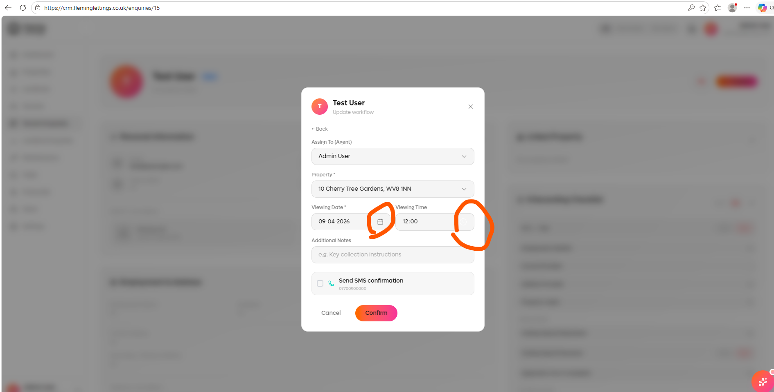
On light mode the icons cannot be seen. Please colour them.

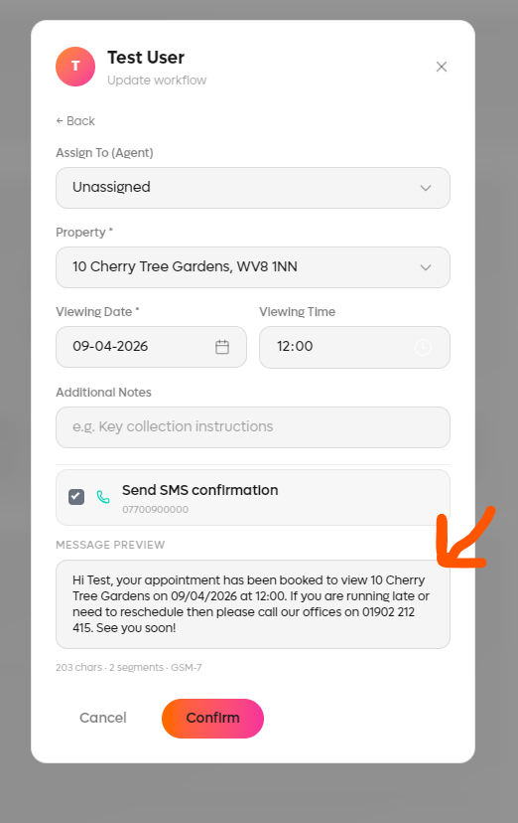
SMS preview for appointment needs to show postcode, i.e. Cherry Tree Gardens, WV8 1NN.

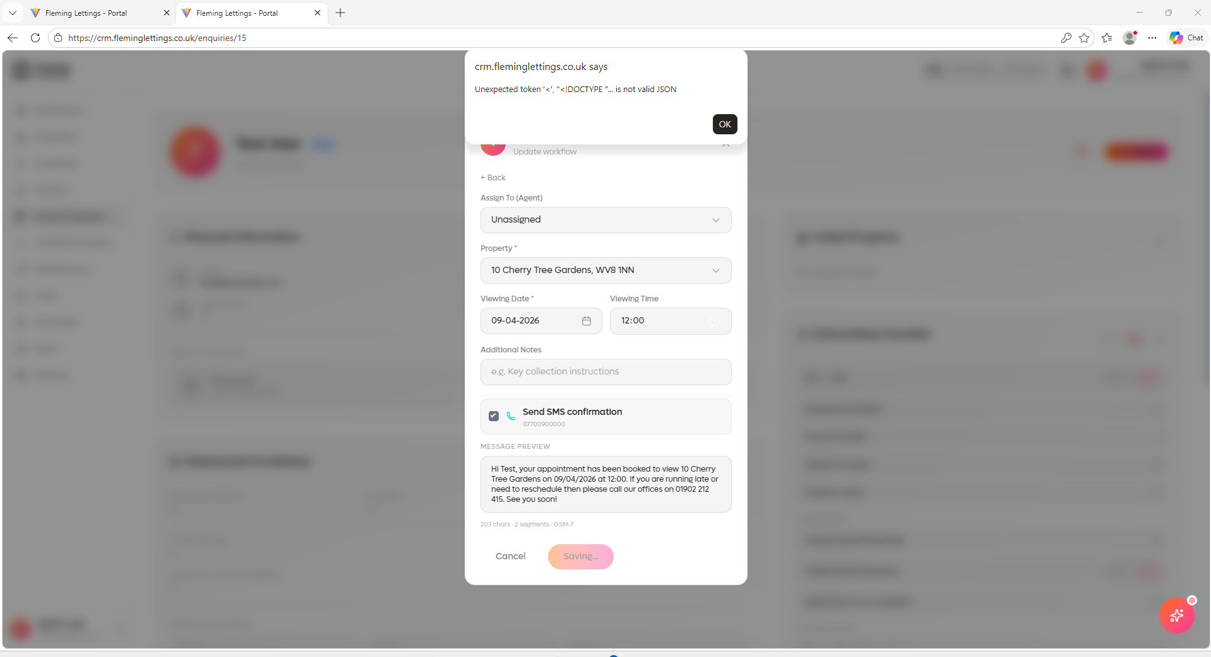
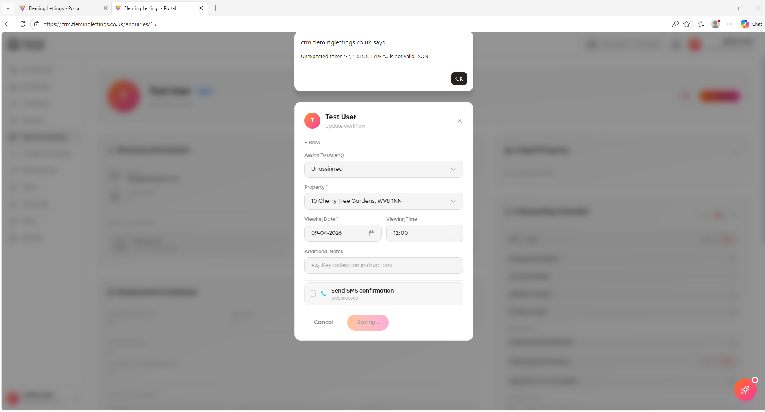
Error message when you try and save the stage for an appointment on tenant enquiry record – or send the SMS for an appointment.

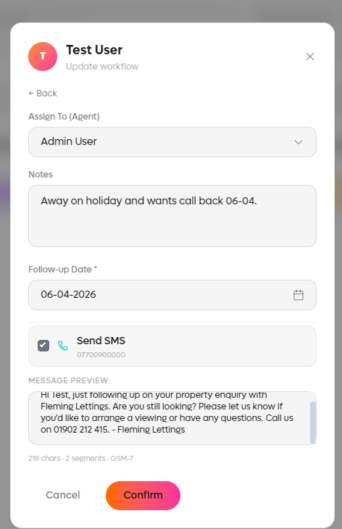
Follow up – update body of SMS preview to:
Hi there! Just following up on your recent property enquiry with Fleming Lettings. When you get five, please call our team back on 01902 212 415. Speak soon, the team at Fleming’s.

When follow up done and SMS selected to be sent out, the record of this message (including date and time stamp) is not showing within the SMS History record section of the tenant enquiry page.

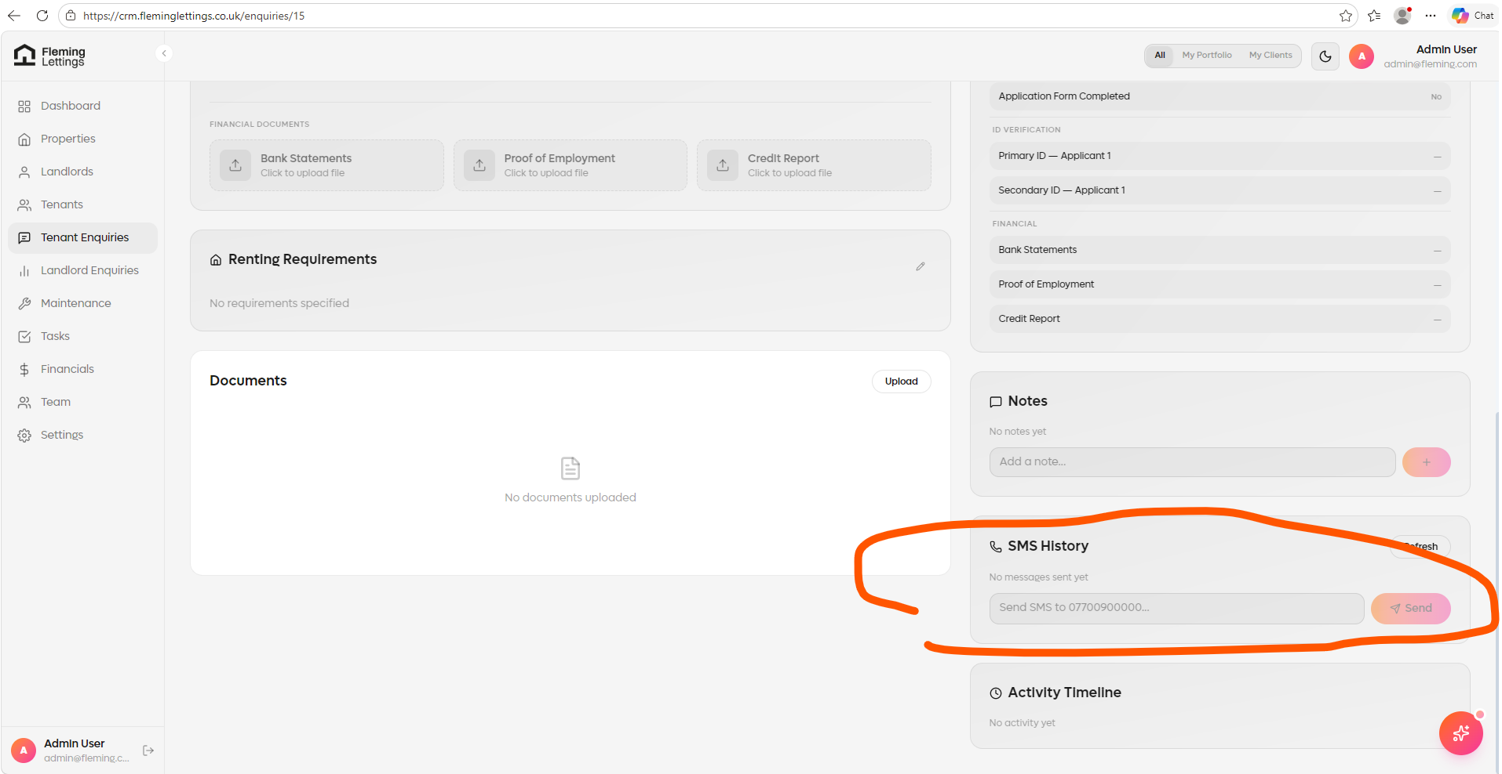

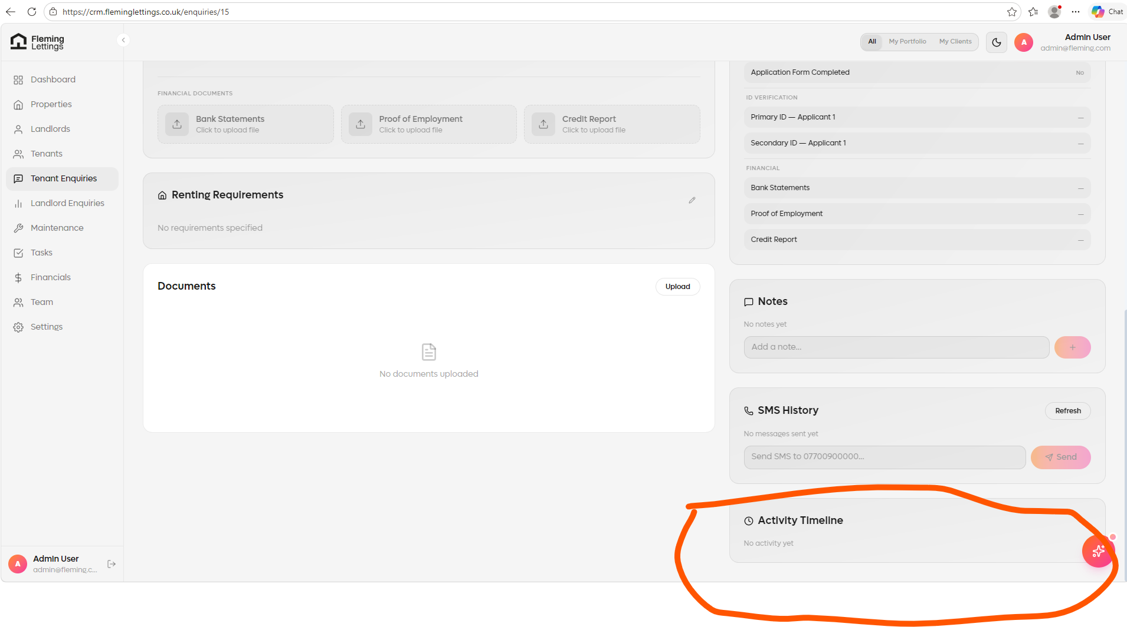
Activity tracking is not working correctly. I have selected this record for a follow up and it should have recorded a log for me viewing the record, then the follow up stage being selected and SMS going out.

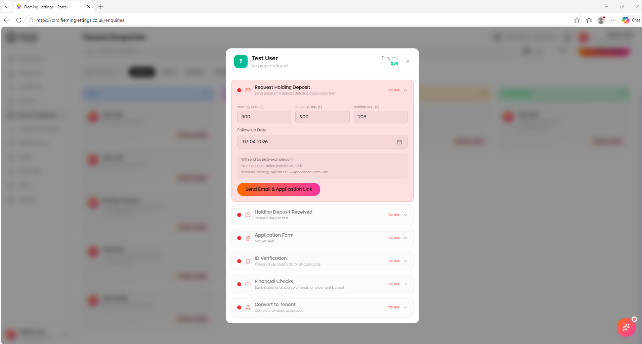
Tenant enquiry record – onboarding. When filling in the Request Holding Deposit form, it should show the user a full preview of the email thread that will be sent out and allow the user to edit it from that view.
Also, when this has been sent out; it should copy a log of this email and save this within a module within the tenant enquiry page itself entitled ‘Email History’ – how the SMS history work. This should be the same across all tenant/landlord/landlord enquiry/tenant enquiry records.

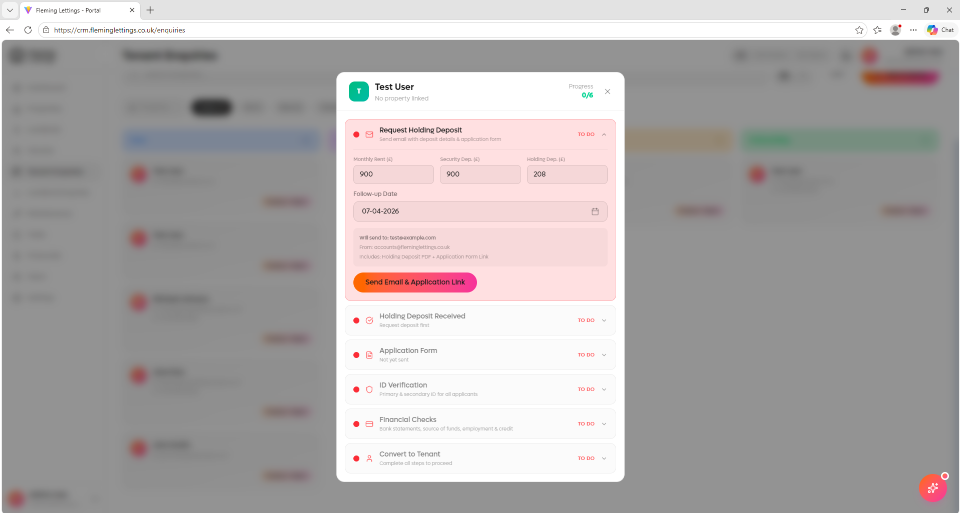
When clicking send email & application link nothing happens, of which means that the stages cannot be progresses. Please sort and rectify this.

